1. **Write a program to generate Fibonacci series**

import java.io.*;

class Fibonacci

{

public static void main(String args[]) throws IOException

{

BufferedReader br=new BufferedReader(new InputStreamReader(System.in));

System.out.println("enter the no of fibonacci's");

int n=Integer.parseInt(br.readLine());

int f1=0,f2=1,f3=0;

System.out.print(f1+"\t"+f2);

int count=2;

while(count<n)

{

f3=f1+f2;

System.out.print("\t"+f3);

f1=f2;

f2=f3;

f3=f1+f2;

count++;

}

}

}

**OUTPUT:**

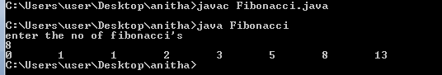

**2. Write a program to check whether the given year is Leap year or not**

import java.io.*;

class Leap

{

public static void main(String args[]) throws IOException

{

BufferedReader br=new BufferedReader(new InputStreamReader(System.in));

System.out.println("enter the year");

int yr=Integer.parseInt(br.readLine());

if((yr%100==0)&&(yr%400==0))

System.out.println(yr+"is a leap year");

else if((yr%100!=0)&&(yr%4==0))

System.out.println(yr+"is a leap year");

else

System.out.println(yr+"is not a leap year");

}

}

**OUTPUT**:

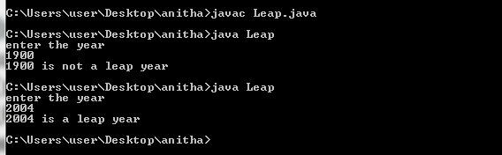

3. **Write a program to check whether the given number is Armtrong or not**

import java.io.*;

class Amstrong

{

public static void main(String args[]) throws IOException

{

System.out.println("enter the number");

BufferedReader br=new BufferedReader(new InputStreamReader(System.in));

String str=br.readLine();

int len=str.length();

int num=Integer.parseInt(str);

int temp=num;

double sum=0;

while(num!=0)

{

int rem=num%10;

sum=sum+(double)Math.pow(rem,len);

num=num/10;

}

if(sum==temp)

System.out.println(temp+" is a amstrong number");

else

System.out.println(temp+" is not an amstrong number");

}

}

**OUTPUT:**

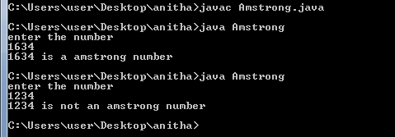

**4. Write a program to check whether the given number is perfect or not**

import java.io.*;

class Perfect

{

public static void main(String args[]) throws IOException

{

BufferedReader br=new BufferedReader(new InputStreamReader(System.in));

System.out.println("enter the number");

int n=Integer.parseInt(br.readLine());

int i=1,sum=0;

while(i<n)

{

if(n%i==0)

sum=sum+i;

i++;

}

if(n==sum)

System.out.println(n+" is a perfect number");

else

System.out.println(n+" is not a perfect number");

}

}

**OUTPUT:**

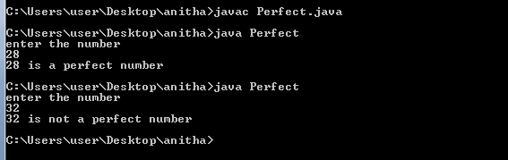

**5. Write a program to find transpose of a given matrix**

import java.util.*;

class Transpose

{

public static void main(String args[])

{

Scanner sc=new Scanner(System.in);

System.out.println("enter the no of rows");

int r=sc.nextInt();

System.out.println("enter the no of columns");

int c=sc.nextInt();

int a[][]=new int[r][c];

System.out.println("enter the elements of the array");

for(int i=0;i<r;i++)

{

for(int j=0;j<c;j++)

{

a[i][j]=sc.nextInt();

}

}

System.out.println("elements of the array before transpose");

for(int i=0;i<r;i++)

{

for(int j=0;j<c;j++)

{

System.out.print(a[i][j]+" ");

}

System.out.println();

}

System.out.println("elements of the array after transpose");

for(int i=0;i<c;i++)

{

for(int j=0;j<r;j++)

{

System.out.print(a[j][i]+" ");

}

System.out.println();

}

}

}

**OUTPUT:**

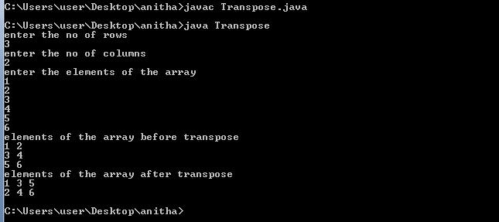

**6. Write a program to add two matrices**

import java.util.*;

class Add

{

public static void main(String args[])

{

Scanner sc=new Scanner(System.in);

System.out.println("enter the no of rows");

int r=sc.nextInt();

System.out.println("enter the no of columns");

int c=sc.nextInt();

int a[][]=new int[r][c];

int b[][]=new int[r][c];

System.out.println("enter the elements of the first array");

for(int i=0;i<r;i++)

{

for(int j=0;j<c;j++)

{

a[i][j]=sc.nextInt();

}

}

System.out.println("enter the elements of the second array");

for(int i=0;i<r;i++)

{

for(int j=0;j<c;j++)

{

b[i][j]=sc.nextInt();

}

}

System.out.println("elements of the first array");

for(int i=0;i<r;i++)

{

for(int j=0;j<c;j++)

{

System.out.print(a[i][j]+" ");

}

System.out.println();

}

System.out.println("elements of the second array");

for(int i=0;i<r;i++)

{

for(int j=0;j<c;j++)

{

System.out.print(b[i][j]+" ");

}

System.out.println();

}

System.out.println("elements of the array after addition");

for(int i=0;i<r;i++)

{

for(int j=0;j<c;j++)

{

System.out.print(a[i][j]+b[i][j]+" ");

}

System.out.println();

}

}

}

**OUTPUT:**

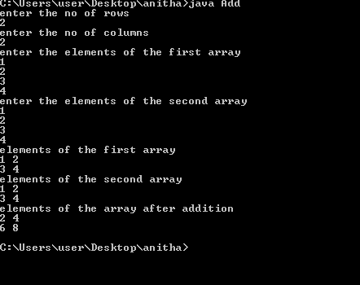

**7. Write a program to multiply two matrices**

import java.util.*;

class Multiplication

{

public static void main(String args[])

{

Scanner sc=new Scanner(System.in);

System.out.println("enter the no of rows of first matrix");

int r1=sc.nextInt();

System.out.println("enter the no of columns of frist matrix");

int c1=sc.nextInt();

System.out.println("enter the no of rows of second matrix");

int r2=sc.nextInt();

System.out.println("enter the no of columns of second matrix");

int c2=sc.nextInt();

int a[][]=new int[r1][c1];

int b[][]=new int[r2][c2];

int result[][]=new int[r1][c2];

System.out.println("enter the elements of the first array");

for(int i=0;i<r1;i++)

{

for(int j=0;j<c1;j++)

{

a[i][j]=sc.nextInt();

}

}

System.out.println("enter the elements of the second array");

for(int i=0;i<r2;i++)

{

for(int j=0;j<c2;j++)

{

b[i][j]=sc.nextInt();

}

}

System.out.println("elements of the first array");

for(int i=0;i<r1;i++)

{

for(int j=0;j<c1;j++)

{

System.out.print(a[i][j]+" ");

}

System.out.println();

}

System.out.println("elements of the second array");

for(int i=0;i<r2;i++)

{

for(int j=0;j<c2;j++)

{

System.out.print(b[i][j]+" ");

}

System.out.println();

}

if(c1!=r2)

System.out.println("Multiplication not possile");

else

{

for(int i=0;i<r1;i++)

{

for(int j=0;j<c2;j++)

{

for(int k=0;k<c1;k++)

{

result[i][j]+=a[i][k]*b[k][j];

}

}

}

}

System.out.println("elements of the array after multiplication");

for(int i=0;i<r1;i++)

{

for(int j=0;j<c2;j++)

{

System.out.print(result[i][j]+" ");

}

System.out.println();

}

}

}

**OUTPUT:**

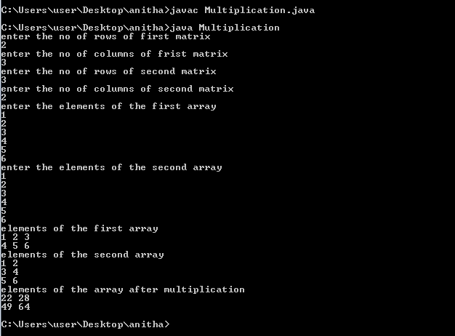

8. **Write a program to sort the array using bubble sorting technique**

import java.util.*;

class Bubble

{

public static void main(String args[])

{

Scanner sc=new Scanner(System.in);

System.out.println("enter the size of the array");

int n=sc.nextInt();

int a[]=new int[n];

System.out.println("enter the elements into the array");

for(int i=0;i<n;i++)

a[i]=sc.nextInt();

System.out.println("Array elements before sorting :");

for(int i=0;i<n;i++)

System.out.print(a[i]+" ");

for(int i=0;i<n;i++)

{

for(int j=i+1;j<n;j++)

{

if(a[i]>a[j])

{

int temp=a[i];

a[i]=a[j];

a[j]=temp;

}

}

}

System.out.println("\nArray elements after sorting :");

for(int i=0;i<n;i++)

System.out.print(a[i]+" ");

}

}

**OUTPUT:**

